

Advice On Preparing Cakes at Home

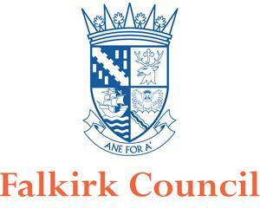

Before you get started make sure you have considered the following:

REGISTRATION

Your home will need to be registered with the Council as a food business. This is a legal requirement. It’s free to register your business. You can find the registration form at Food safety - Register your food business | Falkirk Council. If you wish to discuss this please email the Food & Safety team at fs@falkirk.gov.uk. Remember to include your home address so your enquiry can be allocated to the area officer.

PLANNING PERMISSION

You may need planning permission to run a business from home, so take advice from the planning department of the council. You can contact them at dc@falkirk.gov.uk.

INSURANCE

Just in case things go wrong, we strongly recommend you take out insurance to cover claims against you (third party insurance) in the same way as any other business.
Unfortunately, this can be quite expensive. You should consult your solicitor or insurance agent about this.

RESTRICTIVE COVENANTS

Especially in older properties, you may find that the deeds contain clauses that prevent you from carrying out certain activities and running a food business may be one of them. You should consult your own solicitor about this.

MORTGAGE RESTRICTIONS

If you have a mortgage on your property, you must contact your lender and talk to them about your intentions.

FOOD SAFETY LAW

The laws on food safety apply in the same way to a business run from home as they do to all other commercial premises. Officers from the Council's Food & Safety team will carry out regular inspections. As it’s a business from home these inspections will typically be announced, while most other businesses have unannounced inspections. You should let us know if you use a kitchen somewhere else to prepare food, for example a village or community hall kitchen.

You must also meet the requirements of the Food Information (Scotland) Regulations 2014. There are different requirements depending on how the cakes are packed and ordered. Further information is available at Food labelling regulations & composition | Food Standard Scotland | Food Standards Scotland.

Allergen information/labelling is essential, more information can be found at Food allergy guidance for businesses | Food Standards Scotland | Food Standards Scotland

THE INSPECTION
Catering from home falls under the Food Hygiene (Scotland) Regulations 2006 and Regulation (EC) No 852/2004. These Regulations lay down the requirements relating to persons engaged in the handling of food, the methods and practices used in food businesses and structural matters in food premises.

This is broken down into three areas: Management, Hygiene and Structure

The standards you will have to meet depend upon a number of factors such as the type and quantity of food you intend to prepare, and what else the kitchen is used for, however the following has been produced as a guide on what is expected in most cases to meet the requirements of food law.

MANAGEMENT
FOOD SAFETY MANAGEMENT SYSTEM

All food businesses are required to think about how you will prevent the food that you prepare from being contaminated and ensure it is safe to eat. Contamination falls into three categories: Chemical; Physical and Microbiological.

Hazard | Example
Chemical Contamination | Using cleaning materials that are not 'food safe' / storing chemicals around food
Microbiological Contamination | Not cooking food properly / leaving high risk food (such as fresh cream) out at room temperature / storing baked goods below raw foods causing cross contamination
Physical Contamination | Items falling into bakes (hair/nail varnish) / poor structure of the kitchen (peeling paint/damaged sink seals) / pest control

You are required to have a simple written system in place which shows how you will control these problems. The Cake Makers Hazard Analysis is a short document which you can use to meet this requirement. Complete the blanks in this document to form a food safety management system.

TRACEABILITY

You need to make sure that you can show where all of your ingredients have come from and where your cakes have gone to. Keep hold of all receipts for ingredients brought and keep a record of your customers and dates sold.

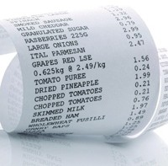

TRAINING

The law requires you to have suitable and sufficient knowledge to ensure that you prepare food safely. You may wish to undertake a food hygiene training course to help achieve this. Courses can be done online or in person.

USE BY/BEST BEFORE DATES

Cakes and biscuits sold in supermarkets are often full of preservatives and may have been specially packed to allow the products to have an extended shelf life.

Best before/use by dates can only be established by microbiological testing of a product.

As this is something which is costly, we suggest a short shelf-life erring on the side of caution. Whilst this is a low-risk product, there could be mould growth and loss of cake quality. You may wish to do some trials (taste and quality) which will help you to confirm this, although you must bear in mind the fact that you cannot see bacteria. As a rule, we would recommend that products are given a shelf life of day of production +2.

HYGIENE

SINKS AND HAND WASHING

Most people do not have a separate wash hand basin in their kitchen. You must ensure that you do however have "adequate facilities for the cleaning of utensils and maintaining adequate personal hygiene".

If you are fortunate enough to be having a new kitchen or sink fitted, we recommend that you install a 1½ or double sink unit. One of these units can then be designated solely for hand washing.

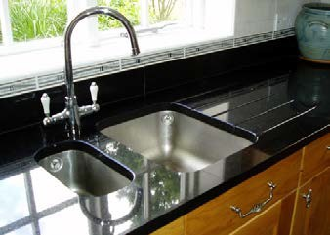

If you only have one sink, you need to consider how you can meet this requirement.

As you will be using your sink in your household's day to day activities, you must ensure that before you start undertaking any baking that you thoroughly clean and disinfect the sink, taps and surrounding area. It can then be used for hand washing whilst you bake.

If utensils are washed in the sink, you must ensure that again the procedure for cleaning and disinfecting the sink after use are implemented.

NOROVIRUS AND FITNESS TO WORK
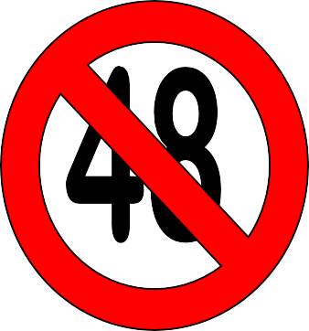
You do not want to be the cause of an outbreak of norovirus or food poisoning (illness involving sickness and diarrhoea) at a function you have prepared cakes for!

If you suffer from sickness and/or diarrhoea you must ensure that you are symptom free (no sickness and/or diarrhoea) for 48 hours before you undertake any baking or cake preparation.

Take the time to consider now what you would do if you had a large order to fulfil and came down ill.

HIGH RISK BAKING

Although most cakes and biscuits are classed as low risk products, some fillings and finishes are more high risk. Fresh cream, some cheesecakes and royal icing made from raw egg whites are all high risk and require extra thought to ensure they are prepared safely.
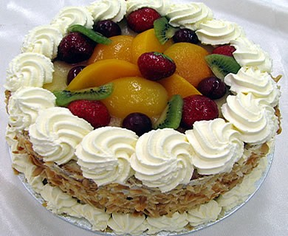

Cakes that require refrigeration must be always kept at or below 5°C with limited time out of temperature control (for example during delivery)

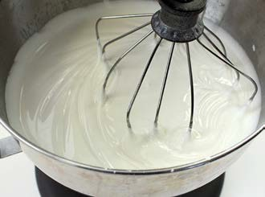

Royal icing is traditionally produced using raw egg whites. This method can still be used; however, we would recommend that lion marked eggs are used, and that these products are not given to vulnerable groups (the young, elderly or pregnant). You can now purchase pasteurised dried egg whites or pasteurised royal icing mixes which remove this risk.

FRIDGE

Any items being kept in the fridge must be stored in a way which does not cause contamination. Raw meat and unwashed salad and vegetables must be stored below ready to eat foods at all times.


You must ensure that your fridge is well organised and running at a temperature of 5°C or below. Use a fridge thermometer to check the temperature regularly.

Don’t overload your fridge. The efficiency of the fridge will suffer if the cooling air circulating within it cannot flow freely.

Keep the fridge door closed as much as possible. Leaving the fridge door open raises the temperature.

If you prepare a large amount of food that needs to be kept in the fridge you may need a separate fridge which is only used for your business.

E-COLI

Making cakes is a low-risk activity, however if you prepare raw meat and unwashed salad and vegetables in your home you could be causing an E. coli risk. You must take care when preparing your food at home to ensure that raw meat is never prepared on the same surfaces as ready to eat foods.

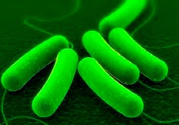

You must make sure that before you begin work that your kitchen is prepared to be your "working kitchen". This will generally mean removing anything not required in the kitchen and thoroughly cleaning and disinfecting the surfaces.

E. coli bacteria and other food poisoning bacteria can grow on the tiniest food source on a dirty work surface. Proper cleaning and disinfecting should also remove all the bacteria from surfaces and equipment involved in food preparation

CLEANING CHEMICALS
You must ensure that you have appropriate cleaning chemicals to keep the kitchen clean and disinfect surfaces and equipment. Disinfectant sprays should meet a certain British Standard (BS EN: 1276 or 13697). Check the label for this information. If you are unsure whether your current sprays meet this requirement you should contact the chemical manufacturer.

Different types of disinfectants require different dilutions and contact times. These are specified and validated by the manufacturer, and you must follow the manufacturer’s instructions for dilution and contact time to ensure the product is effective.

STRUCTURE

YOUR KITCHEN

You must ensure that the structure of your kitchen is kept clean and maintained in good repair and condition as to avoid the risk of contamination.
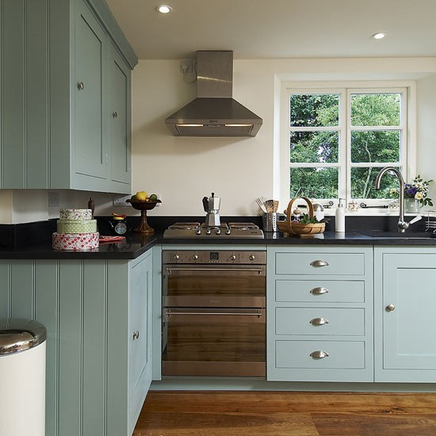
Walls: Need to be a smooth impervious finish (for example tiled or smooth plaster painted with a gloss or silk finish vinyl paint)

Floors: Need to be smooth, impervious, non-absorbent, washable and of non-toxic material (for example sealed Lino or sealed floor tiles with waterproof joints)

Ceiling: Need to be smooth, impervious, non-absorbent, washable and of non-toxic material

TOILETS

Toilets should not open directly into your kitchen. However, in some houses, such as those built in Victorian times the toilet leads straight from the kitchen and cannot be avoided. In these situations, you must ensure that the toilet is well ventilated and the door to the toilet kept shut. People should not use the toilet whilst you are baking.

VENTILATION

You must ensure that you have adequate ventilation in place in the kitchen to prevent condensation, mould growth, and damage to decoration – but make sure open windows don't create a problem with flies and pests!

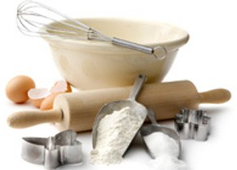

PEST CONTROL
EQUIPMENT

All equipment must be in good condition and not be a potential source of contamination due to its condition or cleanliness.

All equipment should be carefully cleaned, disinfected and stored. You must regularly check equipment and repair/replace anything damage.
You must ensure that your kitchen is always pest free. This can be achieved with regular checking of the kitchen for evidence of pests (droppings/nibbled food). Making sure that no food is left out and that the kitchen is always kept in a clean condition.

Any signs of pest activity should be treated straight away. It is a good idea to record any problems you have and what you did about the problem.

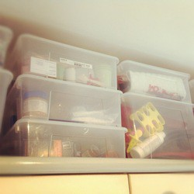
STORAGE

You need to ensure that at all stages of storage, production and delivery the cakes that you produce are free from microbiological, chemical and physical contamination.

Storing equipment, tins and ingredients should be kept separately from your day-to-day items wherever possible. Lidded containers are useful for preventing contaminants falling into tins/equipment whilst it is being stored.

Food in the fridge should be wrapped/covered to prevent items falling/dripping onto others.

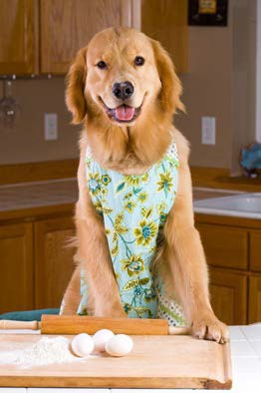
OTHER CONSIDERATIONS

PETS

Having pets is absolutely fine, however you must consider this as part of how you prevent any animal hair etc. from ending up in the food you prepare.

Pets must not be allowed in the kitchen when you are preparing food.

All surfaces/equipment that they may have come into contact with pets must be thoroughly cleaned and disinfected prior to you beginning a baking session.

WASHING MACHINES

A common query is whether you can have a washing machine in the kitchen. We understand that washing machines are generally in domestic kitchens, you therefore need to consider this and ensure that no washing is undertaken at the same time as you prepare food for the business.
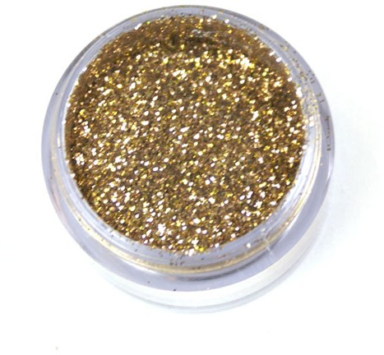

EDIBLE DECORATIONS

Only glitter or dust clearly labelled as ‘edible’ should be applied to food for consumption.

EGGS

We all know that cake makers prefer to use eggs that are at room temperature. It is best to keep eggs in the fridge and to get them out a few hours prior to baking to bring them up to room temperature. Leaving eggs out at room temperature in your kitchen exposes the eggs to lots of changes in temperature, keeping them in the fridge keeps them at a constant temperature.

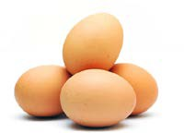

Eggs which are Lion Marked meet a specific safety standard. We recommend that you use eggs with this marking.

ALERGENS

It is a legal requirement for all caterers to provide information if any of the allergens listed below are used as ingredients. Additional requirements are in place if the products are pre-packed for sale to other businesses, or pre-packed for direct sale to your customers. Further information can be found at Food allergy guidance for businesses | Food Standards Scotland | Food Standards Scotland

Peanuts & Other Nuts Eggs
Celery
Molluscs & Crustaceans

Sesame Milk Fish Lupin
Cereals containing gluten Mustard
Soya
Sulphur dioxide/Sulphites
>10ppm

For further information about any of the above please contact the Food & Safety team at fs@falkirk.gov.uk

This document has been reproduced (with amendments) with permission from Coventry City Council

